Adverb Clause

✅ Definition:
# Source: Chatgpt (GPT-4-turbo) at [7/29/2025]
An adverb clause is a dependent clause that functions as an adverb.
It modifies a verb, adjective, or another adverb in the main clause by telling:
When? Where? Why? How? To what extent? Under what condition?

🧩 Structure:
# Source: Chatgpt (GPT-4-turbo) at [7/29/2025]
Subordinating Conjunction + Subject + Verb

🧠 What Does It Modify?
# Source: Chatgpt (GPT-4-turbo) at [7/29/2025]
An adverb clause provides extra information about:
- Time (when)
- Place (where)
- Reason (why)
- Manner (how)
- Condition (if, unless)
- Concession (although, even though)
- Purpose (so that)
- Result (so…that)

🔗 Common Subordinating Conjunctions:
# Source: Chatgpt (GPT-4-turbo) at [7/29/2025]
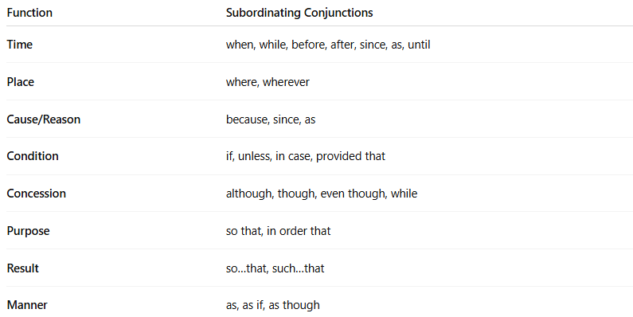

Function | Subordinating Conjunctions
Time | when, while, before, after, since, as, until
Place | where, wherever
Cause/Reason | because, since, as
Condition | if, unless, in case, provided that
Concession | although, though, even though, while
Purpose | so that, in order that
Result | so…that, such…that
Manner | as, as if, as though

✏️ Examples by Function:
# Source: Chatgpt (GPT-4-turbo) at [7/29/2025]
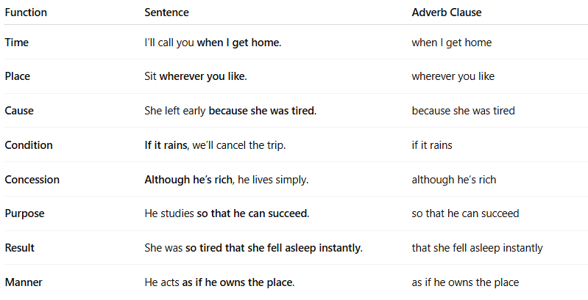

Function | Sentence | Adverb Clause
Time | I’ll call you when I get home. | when I get home
Place | Sit wherever you like. | wherever you like
Cause | She left early because she was tired. | because she was tired
Condition | If it rains, we’ll cancel the trip. | if it rains
Concession | Although he’s rich, he lives simply. | although he’s rich
Purpose | He studies so that he can succeed. | so that he can succeed
Result | She was so tired that she fell asleep instantly. | that she fell asleep instantly
Manner | He acts as if he owns the place. | as if he owns the place

🧠 Important Notes:
# Source: Chatgpt (GPT-4-turbo) at [7/29/2025]
- An adverb clause cannot stand alone.
- It’s usually placed before or after the main clause.
- If it appears before the main clause, use a comma:
  - ✅ Because it was late, we went home.
  - ✅ We went home because it was late.

🔍 Practice – Identify the Adverb Clause:
# Source: Chatgpt (GPT-4-turbo) at [7/29/2025]
- I’ll wait until you arrive.
- Although it was raining, they played outside.
- She ran as fast as she could.
Answers:
- until you arrive → tells when
- Although it was raining → tells concession
- as fast as she could → tells how

